As Ty the I.T. Guy I am highly skilled at building relationships between man and technology. My personal resources and skillsets can eliminate unrealistic goals, present alternative solutions, and provide the services required at a price that will change the way tech support is handled in the future.
During a Tech Savvy Consultation we will go over your tech objectives.
We will create a plan, we will create a budget, and then I’ll offer my Tech Savvy Experience in accomplishing your Tech Savvy Dreams and Projects with A to Z Concierge Services.
I am your I.T. Concierge.
How may I be of Service?
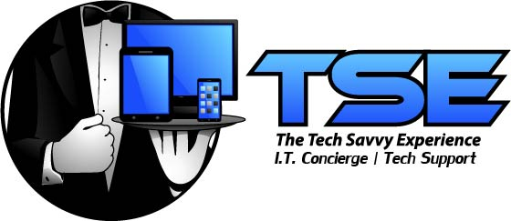
Bring me your Tech Problems and I’ll bring you solutions.
No longer will my clients have to walk into a store alone.
Let Ty the I.T. Guy be your protection from pesky salespeople.
Call Ty the I.T. Guy and Schedule your I.T. Concierge Consultation Today
916-531-9188

I.T. Concierge Services Starting at $29.99

- PC, Laptop, Smartphone, Tablet Setup
- In-store, Online Shopping Lessons
- Concierge Shopping assistance

- In-Home SMART Technology Setups

- Wireless Network Setup & Configuration

- Wireless Printer Setup & Mobile App Configuration

- Software Installation and Configuration

- E-Mail Setup, and Troubleshooting

- Computer Tune-ups and Restorations

- Virus and Malware Removal

- Hardware Installations

- Tech Savvy Training

- Data Recovery

- Data Backup or Transfer

